Oxford Map the System

How might we help New York City build transformative climate adaptation solutions to flood resilience?
Matthias Muehlbauer
Master of Advanced Management, Yale School of Management; Master of Business Administration, Hitotsubashi University Business School of International Corporate Strategy
Winter Wilson
Master of Environmental Management Candidate, Yale School of the Environment

Introduction
Living in New York City is emblematic of the American dream—big city life, full of entertainment and at the heart of the financial world. Buildings overlook the Hudson or East rivers, and when the sun sets, a bustling nightlife begins. To imagine much of the city underwater is to contradict the American psychology on which it stands: that the city and its residents are invulnerable. An assumption parallel with the idea underlying capitalism that there are no limits to growth. That natural resources are abundant. That the climate is unchangeable. These beliefs allow us to live in false realities for the time being. But as sea levels engulf the coast and hurricanes flatten the skyscrapers, the American Dream drowns in the water, too.
On October 29, 2012, Hurricane Sandy hit New York. In just two days, hundreds of homes were destroyed and hundreds of thousands of New Yorkers were left without power or critical infrastructure. Forty-four residents died and the city saw nearly $19 million in damages and lost economic activity (cite). Hurricane Sandy foreshadows a disaster-prone future. The New Yorker details a more subtle threat:
“The deluge will begin slowly, and irregularly, and so it will confound human perceptions of change. Areas that never had flash floods will start to experience them, in part because global warming will also increase precipitation. High tides will spill over old bulkheads when there is a full moon. All the commercial skyscrapers, housing, cultural institutions that currently sit near the waterline will be forced to contend with routine inundation. And cataclysmic floods will become more common, because, to put it simply, if the baseline water level is higher, every storm surge will be that much stronger. Now, a surge of six feet has a one percent chance of happening each year — it’s what climatologists call a “100 year” storm. By 2050, if sea-level rise happens as rapidly as many scientists think it will, today’s hundred-year floods will become five times more likely, making mass destruction a once-a-generation occurrence. Like a stumbling boxer, the city will try to keep its guard up, but the sea will only gain strength.” (cite)
These climate-induced flooding challenges don’t impact New Yorkers equally. In fact, neighborhoods like Coney Island, Jamaica Bay and parts of Lower Manhattan are expected to flood daily at high tide due to sea level rise by 2100 (cite). Communities without sufficient resources to adapt will be left facing the loss of their homes, their communities and even their livelihoods.
Coastal cities around the world face similar challenges. Among 40% of the world’s populations live within 100km of coasts, and with NASA’s predictions of 2 meters of sea level rise by 2100, those cities become increasingly threatened by climate impacts each day (cite). The propositions within this document pertain specifically to New York City’s complex ecosystem of stakeholders, though lessons about transformative climate adaptation measures to improve flood resiliency can be extrapolated for more collaborative climate solutions around the world.

Systems Thinking Approach

We took a deep dive into legislature, understood city reports, attended a New York City (NYC) Town Hall on Environmental Justice, and interviewed over ten individuals in the field across NGOs, the corporate sector and public office. We have communicated our findings through the following frameworks:

- Systems Map
- Iceberg Model
- Causal Loops
- Stakeholder Map
- Existing Solutions Landscape
- Gaps & Levers Model

Systems Map
Our systems map identifies five prominent factors in New York City’s flood resiliency planning challenges:

- Complex & Compounding Adaptation Challenges
- Societal Silos in Climate Collaboration
- Challenges in Climate Funding
- Lack of Adaptation Focus
- Political Challenges in Addressing Climate Adaptation

Complex & Compounding Adaptation Challenges
The Climate Change section of our causal loop diagram focuses on the ways in which climate change drives weather variability, sea level rise and ultimately flooding in New York City. All of this influences and reinforces the compounding climate adaptation challenges in the city.

Societal Silos in Climate Collaboration
What permeates the challenges in climate collaboration is the idea that there is a lack of inter-agency communication and integrated planning when it comes to flood resilience in New York City. This concept shows up in two main categories of challenges: translating science to implementable policy and working to include community members into adaptation efforts in a way that recognizes the inequity resulting from a history of environmental racism within the city. Greenaction defines environmental racism as “the institutional rules, regulations, policies or government and/or corporate decisions that deliberately target certain communities for locally undesirable land uses and lax enforcement of zoning and environmental laws, resulting in communities being disproportionately exposed to toxic and hazardous waste based upon race” (cite). As the Mayor’s Office of Resiliency (MOR) has limited resources to engage with all members of society, individuals and groups have limited understanding of climate change and how institutional racism drives climate justice issues. This results in a set of reinforcing loops leading to societal silos in climate collaboration that inhibits the city’s ability to create effective, holistic and inclusive flood resilience planning.

Climate Adaptation Funding Challenges
The climate adaptation funding challenge focuses on the root challenge that capitalism puts few limits on growth. Since there are few mechanisms within the market to price the negative consequences of environmental degradation, negative externalities are left unaccounted for. The market does not place responsibility on actors for climate change, and in fact has been one reason that funding has been difficult to allocate to the climate sector to the extent necessary. The funding that is available is largely relegated to the climate mitigation realm, which means limited private sector funding for climate adaptation and ultimately challenges funding climate adaptation overall. In the case of New York City, much of the funding available for climate adaptation is federal funding in the form of post-disaster relief and emergency aid.

Political challenges in addressing climate change adaptation
From our conversations with the MOR and other relevant stakeholders within the NYC political ecosystem, we discovered that much of the climate adaptation work and decision making is relegated to the Mayoral level. This, however, is challenged by state level politics, which are heavily influenced by the real estate lobbyists and the insurance industry, which have a stake in being able to develop within floodplains and on the coast. This means that populist policies tend to prioritize mitigation when it comes to climate change, leading to a lack of long-term planning beyond election cycles that effective climate adaptation needs. Our research identified at least 37 individual agencies scattered across Federal, State, and City regions interacting with decision making on climate resiliency (Boicourt, 2021).

These challenges are compounded by the lack of interagency communication, accountability and integrated planning which becomes unraveled when democratic cycles drive the next Mayoral race. The 2021 race, in itself, has largely halted climate resilience work as city officials wait for which Mayoral commitments will align with resiliency projects.

Lack of Adaptation Focus
The psychology and mental models underlying the lack of focus on adaptation neglect the need to think long-term about the climate crisis. This is described through a particular human bias tendency to discount the future (hyperbolic discounting from Thaler, 2009). Compounding this discounting is the western philosophy driven nature of analysis that can be traced back to Descartes decoupling of the mind and spirit (Descartes, 1637) and perpetuating the analysis of the world through a lens where people value analysis of the parts over the sum. This leads to Methodological Reductionism, the literal antithesis to systems thinking.

On top of this lies the psychology of a New Yorker: often considered to be brash, rude and unapologetic. They are tough and resilient in the face of challenges, and this is no different in the face of the climate crisis, where a resilient policy tone talks about “embracing the coasts” (cite). This framing speaks volumes, as it infers a mindset about being able to defeat and beat back climate change instead of embracing climate adaptation measures.

Iceberg Model
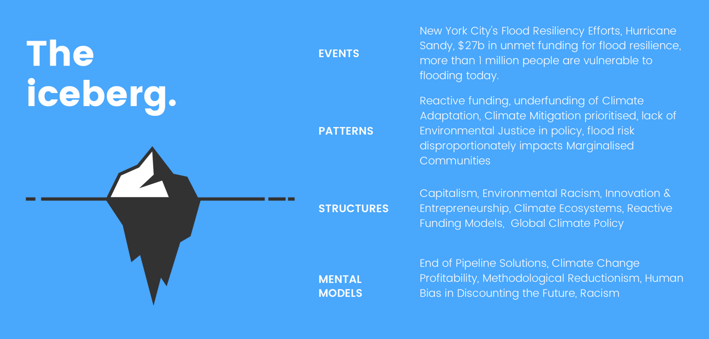
Figure 1. Flood Resiliency Iceberg Model.

See appendix A for the expanded list of items categorised into our Iceberg Model.

Our iceberg model shows the layers associated with New York City’s challenges with flood resilience and climate change adaptation. More than 1 million people in the city are vulnerable to flooding (cite), with layers of systemic challenges reinforcing the problem that climate adaptation is not only under prioritized and underfunded, but part of more deeply rooted issues like racism and human bias in discounting the future.

Causal Loops

Figure 2. Causal Loop Systems Map.

See above for our systems map and refer to our diagram for further understanding of the smaller loop structures underlying our model (cite).

Stakeholder Map

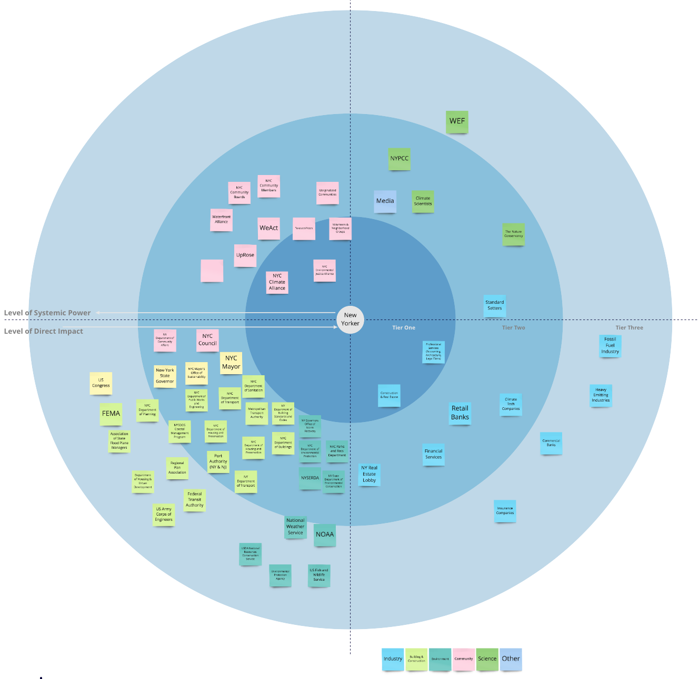
Figure 3. Stakeholder Map.

Our Stakeholder Map was designed with our New Yorker, at risk of flood and vulnerable to the impacts of climate change, at the center. As we move away from the center, the level of systemic power increases. Conversely, as we move from the outside to the center, the level of direct impact to our stakeholder increases.

Over 37 government agency stakeholders are involved in climate resiliency decision making. This bureaucracy is fundamentally slow, and naturally these stakeholders hold the most systemic power and influential role in creating change. Tier three government stakeholders tend to provide direction in the form of legislation and can direct human and financial capital in the most meaningful way through this power.

We also observed that direct stakeholders in the closest tier to our vulnerable New Yorkers are community-based organisations that tend to have limited power and influence in creating systems change.

Existing Solutions Landscape
We prioritized relevant solutions based on our own criteria below, and found gaps in effectiveness: presenting an opportunity for solutions with long-term thinking, community-focus and community collaboration.

- Is this a long term solution?
- Does this take into account all available information (e.g. scientific facts, stakeholder inputs)?
- Is this a proactive or reactive solution?
- Does this provide better information to aid decision making?
- Is this solution connected and integrated from policy and strategy to execution?

Governmental | NGO | Business | Local
Federal government provided $4.2 billion in Community Block Funding but only to 2022 - MOR has to rush through last minute projects to utilise remaining funding. (cite) | NYC Climate Alliance seeks to lobby legislation, but this is mitigation-focused (Gracer, 2021) | Financial services firms are exploring methods of assessing their portfolios for climate risk to understand exposure from climate signals such as flooding, extreme precipitation etc. | NYC Environmental Justice Alliance brings together marginalized communities and integrates them into the community planning process as seen at the NYC Town Hall for the 2023 report on Environmental Justice
OneNYC, New York City’s 2050 resiliency vision is “Strengthening communities, buildings, infrastructure, and a more resilient waterfront” (cite) | Waterfront Alliance seeks to add climate resiliency principles to legislation & planning (Boicourt, 2021) | Climate Technology companies with community engagement models like I See Change integrate community - sourced data collection methods to inform better maps (cite) or public and private data to predict climate signals (cite)
Gaps in FEMA flood maps have caused challenges for use within the City Planning process for resiliency (Schmid, 2021) | WeAct brings together a joint community from Northern Manhattan and historical marginalized communities to give a voice, and a seat at the table for planning decisions | Insurers struggle to insure assets in high risk flood plains due to the high risk of payout - usually pricing homeowners out of the market (Kim, 2021)
Federal funding sets a discount hurdle rate of 7% to fund projects - this is not fit for purpose for climate adaptation solutions (Schmid, 2021)

Figure 4. Existing Solutions Landscape.

Reactive funding models: Funds provided post-disaster
Context: “Roughly $4.2 billion was received in Community Development Block Grant - Disaster Recovery funding to cover rebuilding and rehabilitating housing, assisting displaced tenants, providing aid to businesses, and bolstering coastal defenses.”(cite)

Issue: Funding has been reactive, with limited funding provided for time horizons beyond 10 years. Currently, the Mayor’s Office of Resiliency is scrambling to spend funds running out by 2022, whilst also creating a bottleneck as city officials wait for more Federal funding to be greenlit beyond 2022 (Schmid, 2021).

Current financial systems and market mechanisms are incompatible with climate adaptation solutions
Context: Federal funding and budgets use cost-benefit-analysis to determine which projects will receive funding. The federal government generally uses 7% as a benchmark discount rate (Schmid, 2021) in project assessment.

Issue: Adaptation projects typically have different value profiles over time, whereby value increases on a much longer timeframe than traditional financial projects where discount rates are relevant (e.g. 3-10 year projects). Considering seawalls as a form of coastal or flood resiliency, their value increases when rising sea levels get higher - before that point, the seawalls present a myriad of community issues held with the ongoing East Side Coastal Resiliency Project (cite). In another example, using natural coastal vegetation provides a natural, biological asset which will provide coastal protection - the 7% hurdle rate (Schmid, 2021) is challenging due to the slower growth of the asset and its inability to capture other benefits that sit outside financial systems, such as the beneficial impact to water quality and the ability to absorb stormwater in the case of flood and rising sea levels.

FEMA Flood Maps have been ineffective amidst technology failure
Context: FEMA provides flood maps which are used by the MOR for capital and resiliency planning (Schmid, 2021). These maps are also used by the insurance industry to identify high risk areas for properties.

Issue: Ultimately, federal agencies have struggled with data and technology (e.g. LIDAR), with inaccuracies and outdated New York City maps prevalent. The MOR has not been able to use 2015 maps due to inaccuracy, and in wanting to reduce liability, have erred on the side of caution to make planning decisions.

Community interaction models are broken

Context: The Rebuild by Design Initiative was initially slated to be an exciting community-led initiative to reimagine New York City’s coastline that would bring key actors from government, business sector, not-for-profit and community organisations (cite).

Issue: Due to siloed stakeholders and inadequate planning, solutions quickly became challenging to implement. This is not uncommon due to the fragmented way the different Boroughs approach resiliency projects based on neighbourhood. Currently there is no consistent plan - rather, each neighbourhood uses different stakeholder engagement policies and guidelines, often creating inequity.

Inability to price externalities has allowed actors to continue ignoring the climate crisis
Context: The inability to price externalities has been driven by the inability to integrate a market-based carbon price, which has allowed companies to avoid accountability in the climate crisis.

Issue: Due to the inability to ascribe value to business’ climate impact, allocating funding and resources to the right business activities is a challenge, and private actors are not incentivised properly.
This is driven by lack of standardized carbon measurement, no joint understanding of Net Zero (cite), and lack of voluntary reporting requirements (e.g. SASB, TCFD).

Potential Opportunities

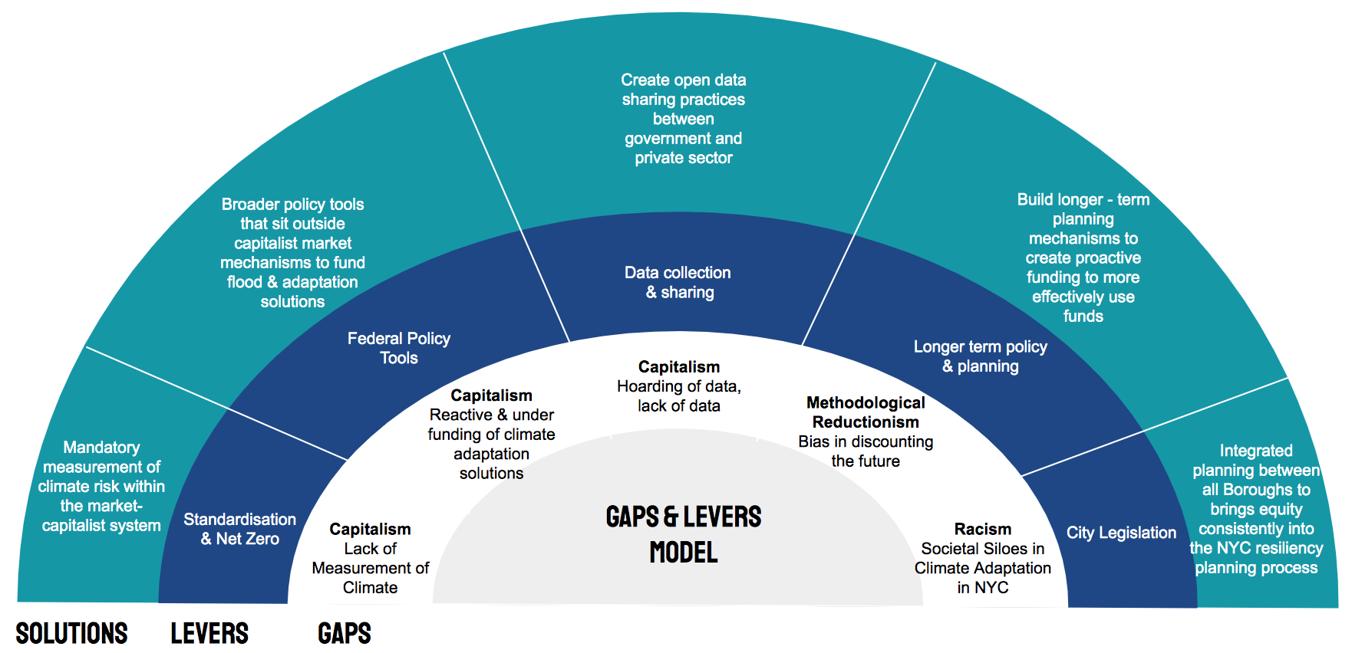
Figure 5, Gaps & Levers Model

- Underlying structure: Capitalism. The system lacks measurement of climate risk and standardized carbon accounting alongside a Net Zero definition (cite). Mandatory regulation will create accountability for companies, better direct investment flows and incentivise businesses towards flood resiliency.
- Underlying structure: Capitalism. Federal-level policy tools should be created to assess the value of a broader set of resiliency solutions that sit outside traditional financial tools and market mechanisms.
- Underlying structure: Capitalism. Private and Public sector need more collaboration on data-sharing (e.g. NOAA, FEMA), to enable innovative models of tracking and predicting weather patterns and climate physical risk [e.g. Cervest (cite), I See Change (cite)].
- Underlying structure: Methodological reductionism: Federal funding should provide proactive funding for climate adaptation and flood resiliency solutions. A shift in the mental model that avoids the human bias to discount the future, and solutions using longer planning cycles, as suggested by NYC legislation currently tabled (cite), is necessary. Interestingly, at the time of writing, Mayor Bill De Blasio just passed legislation Int. 2092 (cite) to include climate resilience guidelines as part of the Office of Long Term Planning and will require integration of climate resiliency metrics (cite).
- Underlying structure: Racism. More integrative planning with the community being both input, and decision maker into planning decisions is needed to counter historical institutional racism driven climate justice issues.

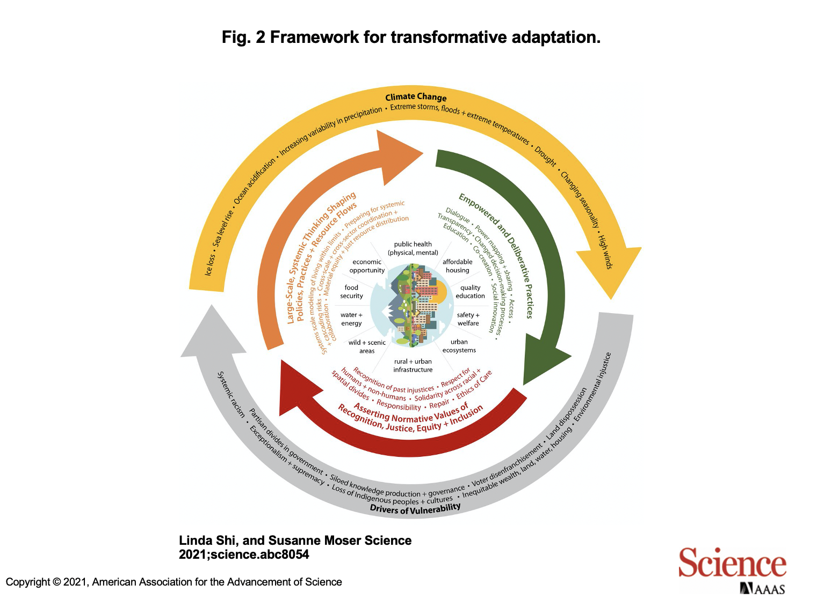
Figure 6, Transformative Adaptation Framework

The above framework tackles geophysical climate conditions, root causal drivers of vulnerability and adaptation strategies concurrently. It creates a framework that allows reflection on “shared traumas, shared values, and mutual interdependence of communities” in living with climate change (cite). While our proposed solutions and levers focus predominantly on the systemic thinking aspects of this framework, careful consideration of empowerment and justice are crucial. Only through screening existing and future solutions with this framework can effective, holistic and sustainable solutions be created.
As NYC works to create an effective climate adaptation strategy, the city should be careful not to neglect “underlying social relationships and power dynamics,” and run the risk of preserving the status quo (cite). Instead, “transformative adaptation is not just about “climate-proofing” existing structures and systems, but about deliberately and fundamentally changing systems to achieve more just and equitable adaptation outcomes. This implies investigating the factors that maintain the status quo and strategically addressing them to intentionally shift systems in new directions.” (cite)

Lessons Learned and Key Insights

This is the first step in addressing this complex system in NYC. The New York City Mayor’s Office of Resiliency especially, is keenly interested in our findings and what they reveal about the possible paths forward for the city.

Calculating and addressing the climate crisis into the existing capitalism-influenced structures in New York City has underscored a large amount of historical climate inaction. Deep structures around racism and resident psychology also permeate these complex systems and augment the challenge of flood resilience and climate adaptation. Better collaboration between societal siloes is likely to harbour greater harmony, more equity and better societal outcomes amidst the climate crisis.

Bibliography

Sources

Boyd, Peter & Pickett, Casey, “Defining Net Zero: Addressing Climate Change Requires Clear, Bold Explanation of Our Shared Global Goal”, Yale Center for Business & Environment, Accessed 25 February 2021 at https://cbey.yale.edu/sites/default/files/2020-07/CBEY_NET-ZERO_July_17_2020.pdf

Cervest, Company website, Accessed on 18 March 2021 at https://cervest.earth/

City of New York, “About Hurricane Sandy”, Accessed on 19 March 2021 at https://www1.nyc.gov/site/cdbgdr/about/About%20Hurricane%20Sandy.page

City of New York, “PlaNYC: A Stronger, More Resilient New York”, Accessed on 10 March 2021 at http://s-media.nyc.gov/agencies/sirr/SIRR_singles_Hi_res.pdf

City of New York, “OneNYC: Building a Strong and Fair City”, Accessed on 11 March 2021 at https://onenyc.cityofnewyork.us/wp-content/uploads/2019/05/OneNYC-2050-Summary.pdf

City of New York, “The East Side Coastal Resiliency Project”, Accessed on 11 March 2021 at https://www1.nyc.gov/site/escr/index.page

Descartes, René, “Discourse on the Method of Rightly Conducting One's Reason and of Seeking Truth in the Sciences”, Accessed on 12 March 2021 at http://www.earlymoderntexts.com/assets/pdfs/descartes1637.pdf, 1637

Edmonds, Pete, Chona, Daniela & Meng, Lesley, “Net Zero: The Next Frontier for Corporate Sustainability”, Yale Center for Business & Environment, Accessed on 1 March 2021 at https://cbey.yale.edu/sites/default/files/2021-01/CBEY_NET-ZERO-FINAL_Jan2021.pdf

GreenAction, “Environmental Justice & Environmental Racism”, Accessed on 23rd May 2021 at https://greenaction.org/what-is-environmental-justice/

I See Change, Company website, Accessed on 18 March 2021 at https://www.iseechange.org/

Muehlbauer, Matthias & Wilson, Winter, “How Might We Help New York City Build Transformative Climate Adaptation Solutions to Flood”, https://www.kumu.io/mbauer/how-might-we-help-new-york-city-build-transformative-climate-adaptation-solutions-to-flood-resilience

New York City Council, “Planning Together: A New Comprehensive Planning Framework for New York City“, Accessed on 19 March 2021 at https://council.nyc.gov/news/2020/12/16/planning-together/

New York City Council, “Int 2092-2020: Climate resiliency design guidelines and resiliency scoring”, Accessed on 18 March 2021 at https://legistar.council.nyc.gov/LegislationDetail.aspx?ID=4648590&GUID=F7CCBD21-44D7-4280-AB54-3D419D2AE033&Options=&Search=

New York City Environmental Justice Townhall, attended on 25 March 2021

Nonaka, Ichijiro & Takeuchi, Hirotaka, “The Knowledge Creating Company”, Oxford University Press, 1995.

Rebuild by Design, Company website, Accessed on 17 March 2021 at http://www.rebuildbydesign.org/about

Shi, Linda & Moser, Susanne, “Transformative climate adaptation in the United States: Trends and prospects”, Accessed on May 21st 2021 at https://science.sciencemag.org/content/early/2021/04/28/science.abc8054

Thaler, Richard, “Nudge: Improving Decisions About Health, Wealth, and Happiness”, Penguin Books, 2009

The Verge, “How New York is Preparing for the next superstorm, six years after Hurricane Sandy”, accessed on 23 February 2021 at https://www.theverge.com/2019/11/21/20976248/mta-floods-test-nyc-subway-climate-change-equipment-flex-gate

Verge Science, “How NYC plans to survive the next superstorm”, video accessed on 23 Febraury 2021 at https://www.youtube.com/watch?v=F3HABFr1Gys

Waterfront Alliance, “What we do”, Accessed on 15 March 2021 at https://waterfrontalliance.org/what-we-do/resilience/

Video & music Sources

NYC Department of City Planning, “Planning a Resilient New York City”, Accessed May 21 2021 at https://www.youtube.com/watch?v=6QJYgm0fRHk

Hussein, Sarowar, “The Seascape New York Harbor”, Accessed May 21 2021 at https://www.pexels.com/video/the-seascape-new-york-harbor-4793622/

Hussein, Sarowar, “The New York City Skyline During Sunset”, Accessed May 21 2021 at https://www.pexels.com/video/the-new-york-city-skyline-during-sunset-5384041/

Hussein, Sarowar, “Nautical Mile Freeport New York”, Accessed May 21 2021 at https://www.pexels.com/video/nautical-mile-freeport-new-york-5626405/

Ingels, Bjarke “Future New York - $335 million to increase resiliency in Lower Manhattan The Big U by Bjarke Ingels”, Accessed May 21 2021 at https://www.youtube.com/watch?v=GEmVETFPR3c

Marripati, Bhargava, “Footage of People and Surroundings of the busy Times Square Street”, Accessed May 21 2021 at
https://www.pexels.com/video/footage-of-people-and-surroundings-of-the-busy-time-square-street-3202634/

Verge, “This is what sea level rise will do to coastal cities”, Accessed May 21 2021 at
https://www.youtube.com/watch?v=6tesHVSZJOg

Is That You or Are You You by Chris Zabriskie is licensed under a Creative Commons Attribution 4.0 license. https://creativecommons.org/licenses/by/4.0/
Source: http://chriszabriskie.com/reappear/
Artist: http://chriszabriskie.com/

Interviews

Neil Yeoh, CEO & Founder, OnePointFive
Maki Tazawa, Sector Manager, Natural Capital, CREOS Syndicate, Former-Runner-Up Oxford Map the System 2019
Mike Blumenfeld, NYU Professor of Entrepreneurship
Sam Horowitz, Yale School of Environment Master of Environment Candidate and Ex-Intern at New York City Mayor’s Office of Resiliency
Amy Kim, Climate Modeler, QBE Insurance
Jeffrey Gracer, Chairman of NYC Climate Alliance
Peter Boyd, Lecturer at Yale School of Environment, ex-COO of Carbon War Room, ex-External Advisor to UK Department of Energy and Climate Change
Kate Boicort, Director of Resilience, Waterfront Alliance
Kathleen Schmid, Deputy Director, Program Coordination and Delivery, NYC Mayor’s Office of Climate Resiliency
Julian Macrone, Yale School of Environment Master of Environment Candidate and Ex-Associate Director, New York Fort Greene Conservancy
Lauren Wang, Senior Policy Advisor, NYC Mayor’s Office of Climate Resiliency

Appendix A
